MOHAMAD DUKUREH
mohamad.dukureh@lc.cuny.edu
CMP 420-Database Systems
4/28/2025

SCHOOL DATABASE
BY MOHAMAD DUKUREH
Introduction

As a database architect, you have been hired by the Department of Computer Science to design their database. The database keeps track of all the employees in the department, courses offered by the department, and students majoring or minoring in programs offered by the department such as computer science, computer information systems, cybersecurity, data science and AI. The employees are categorized into faculty and staff. The assumptions that I have while making this project was My assumptions while making an rational model was that weak entity did not have a key, but it does an partial key. A student enrolls in a course instead of a course section. A ssn can key in this database because in the real world because to access your student information u need ssn to gain access to name and address. In normalizing the employee entity, I thought it could be two primary keys but there only one primary key. Also thought there only can be only primary key another assumption is the student grade could be in the enrollment entity because the student receives a grade after he enrolled the class and completed the course.

Entity Relationship Model Diagram (ER diagram or EER)
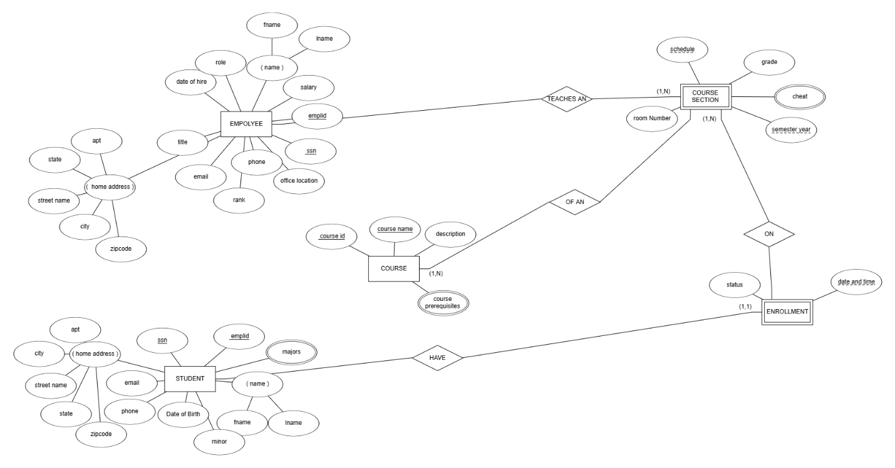

In this ER diagram, I created an entity employee which is a strong entity on the diagram and added atomic(single) attributes which were phone, email, salary, office location, and date of hire, title, role, rank, emplid and ssn which is a unique key that helps to identify the to other attributes. And composite attributes name and home address, so I break into multiple parts to reduce redundancy. I connect the relationship between the employee with the course section because teachers teach multiple course sections of different courses.
For the student entity an another strong entity I made on the diagram. The student entity provides a unique key ssn and emplid which help to identify the student. The atomic attributes that I added on the er diagram were Date of Birth, email, phone, and major which is an multivalued attribute because student could have multiple majors and composite attributes name and address which must be broken into parts. I make a relationship with the entity student and enrollment because a student enrolls in a course section of an course.
For the course entity, I added the atomic attributes course name, course id which is an unique key, description and the multivalued course prerequisites because there can be an course that has more than one course prerequisites. Make an relationship with the course with the course section because the course could have different course sections.
For the course section, entity which is an weak entity that has no unique key but partial keys. I added the semester year and schedule as partial key because them together identifies the course section. I added grade and room number as attribute and cheat as an multivalued because students could cheat in multiple courses. I made an relationship with the course section with course because their course section of an course and an enrollment and course section because an student enrolled in an course section.
Lastly for the enrollment entity, added an partial key date and time because an student enrolled in certain date and time and an atomic attribute status which is if student either completed, dropped or active in the course. I added an relationship with enrollment and student which is an one to many relationship because a student could have many enroll in different courses and enrollment with course section because an student enrolled in an course section.

Relational Model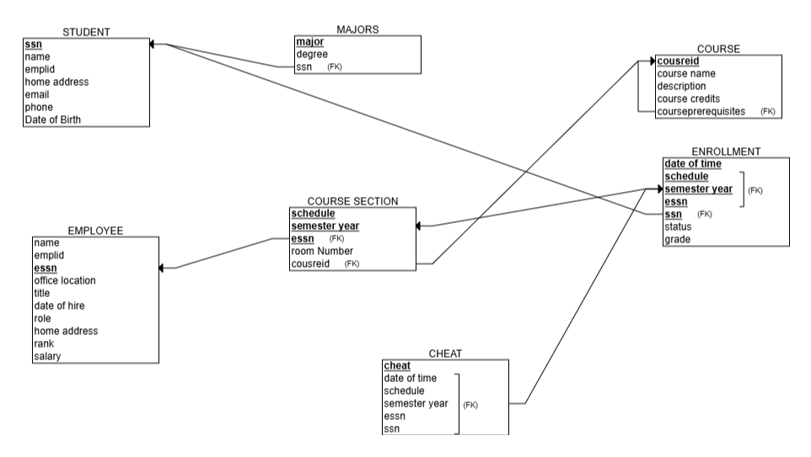

For the relational model I start with the strong entity, for the employee entity I added atomic(single) attributes which were phone, email, salary, office location, and date of hire, title, role, rank, emplid and essn which is a unique key, so it underlined.
For the student entity I added the atomic attributes that I added on the er diagram were Date of Birth, email, phone, and composite attributes name and address and major as their own relation with an degree with an foreign key emplid and ssn that reference back to student since it an multivalued attribute and the emplid and ssn is it also underlined since it an unique key.
For the course entity it has the atomic attributes course name, course id which is an unique key, description and the multivalued course prerequisites as it own relation as an entity with course prerequisite as a primary key with course id and course name as foreign key that references back to course.
Then I added the weak entity course section with the attributes of the semester year and schedule as partial key, grade and room number as attribute. And cheat have its own relation as primary key that have the ssn and emplid as foreign key that references back to employee and the ssn and emplid as a foreign key that references back to student since it an multivalued because students could cheat in multiple courses.
Lastly for the enrollment entity I added the attributes date of time an partial key and status with the foreign key emplid and ssn that reference back to the student because student enroll a course. The course name and courseid as foreign key because course have an course section so it has reference back to the course entity.

Normalization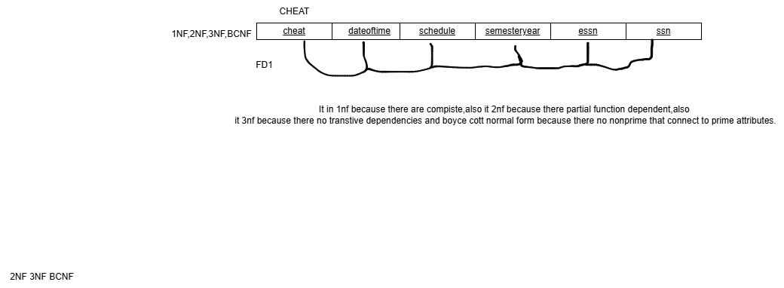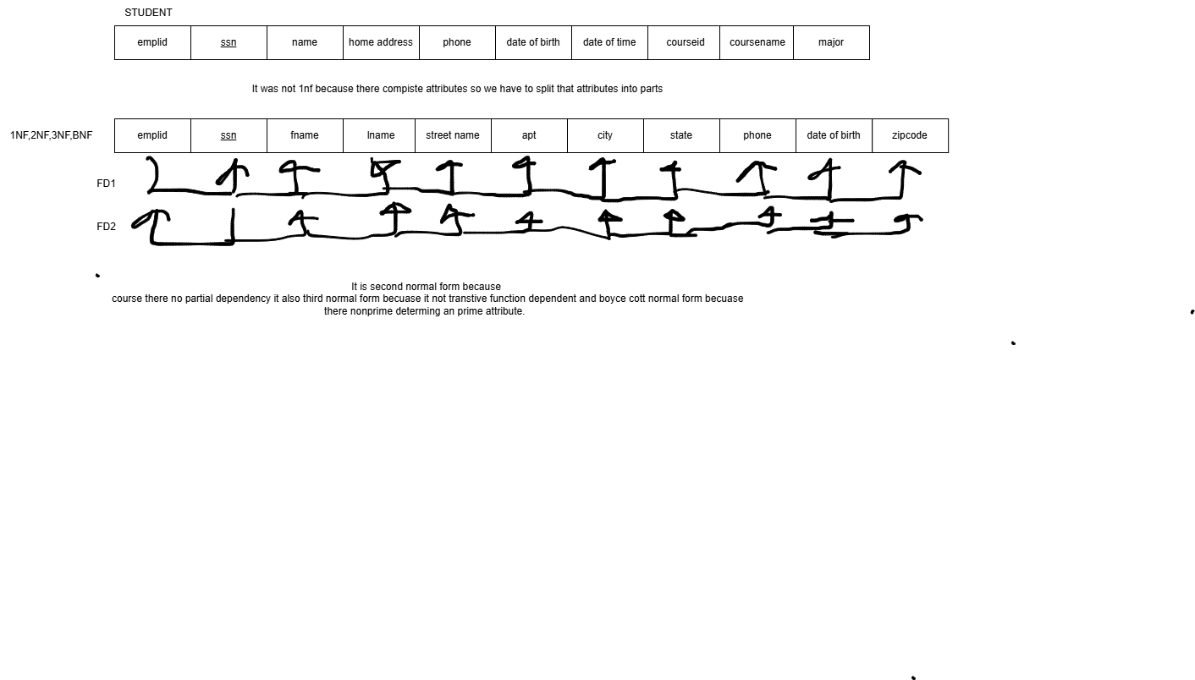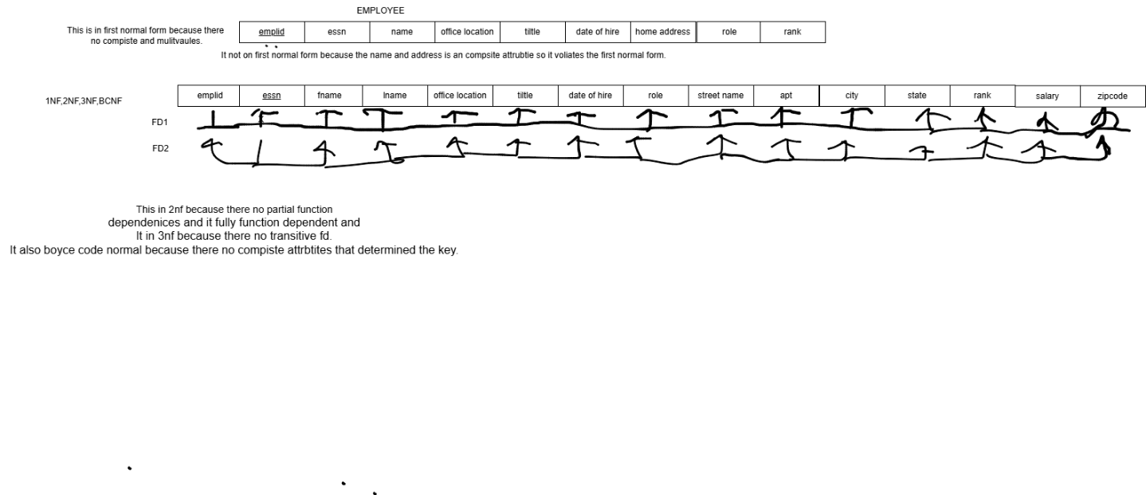
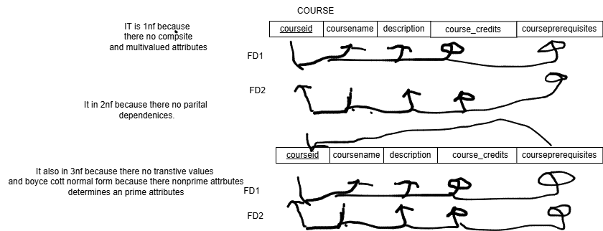

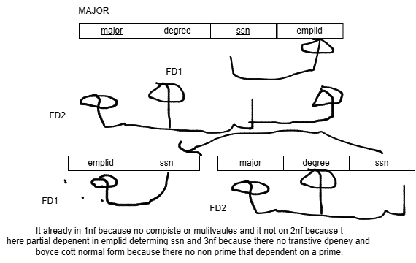

SQL QUERIES
CREATE DATABASE IF NOT EXISTS school;
use school;
SET foreign_key_checks = 0;

DROP TABLE employee;
CREATE TABLE employee(
fname varchar(30) not null,
lname varchar(30) not null,
essn char(9) not null,
eemplid char(9) not null,
officelocation varchar(6),
title varchar(30),
dateofhire date,
erole varchar(15),
erank varchar(15),
salary decimal(10,2),
streetname varchar(30),
apt varchar(3),
state varchar(20),
zipcode varchar(6),
primary key (essn)
);

INSERT INTO employee
values("Steven","Fulakeza","123987811","224567117",
"GI 232","Computer Science Professor","2016-10-01","Professor","Insturctor",
"60000","123 Morris Ave","37","New York","10459"),
("Geoffrey","Kelly","145698093","234587117","GI 123","Computer Science Professor","2017-10-18","Professor","Insturctor",
"80000","123 Webster Ave","39","New York","10459")
,("Renato","Bettiol","149123567","234587117","GI 234","Mathematics Professor","2017-11-18","Professor","Insturctor",
"90000","145 Grant Ave","39","New York","10459"),
("Mingxian","Zhong","135901987","23667117","GI 123","Computer Science Professor","2017-10-20","Professor","Insturctor",
"90000","155 Third Ave","50","New York","10459"),
("Robert","Schneiderman","149123675","239567117","GI 125","Mathematics Professor","2017-10-19","Professor","Insturctor",
"90000","151 Grant Ave","50","New York","10459"),
("Alexandra","Idso","135901235","234567119","DH 418","Science Professor","2017-10-19","Professor","Insturctor",
"90000","145 Grant Ave","50","New York","10459"),
("Gabriel","Pastor","135892091","234587117","GI 321","Science Professor","2017-10-19","Professor","Insturctor",
"100000","145 Fordham Road","10","New York","10458"),
("Vanesa","Caban","136091234","231567117","GI 321","Science Professor","2017-10-19","Professor","Insturctor",
"10800","145 Webster Ave","10","New York","10459"),
("Nathaniel","Finkelstein","136095691","234067117","CH 321","English Professor","2017-10-19","Professor","Insturctor",
"5000","145 Grand Concourse Ave","10","New York","10459"),
("Eva","Sofianos","136564321","234967117","GI 324","Computer Science Professor","2019-10-19","Professor","Insturctor",
"1000","145 Webster Ave","11","New York","10459"),
("Andrew","Jones","136091897","231567117","GI 123","Computer Science Professor","2017-10-19","Professor","Insturctor",
"1009","145 Molersoe Ave","10","New York","10459"),
("Micheal","Jones","136876235","234567417","GI 123","Computer Science Professor","2017-10-19","Professor","Insturctor",
"100000","145 Molersoe Ave","10","New York","10459"),
("Steve","Johnson","136876238","234967917","GI 123","Computer Science Professor","2017-10-19","Professor","Insturctor",
"40000","145 Molersoe Ave","12","New York","10459"),
("Mark","Johnson","136876287","234507117","GI 123","Computer Science Professor","2017-10-19","Professor","Insturctor",
"50000","145 Molersoe Ave","15","New York","10459"),
("Mo","Blackson","136896209","234567617","GI 137","Computer Science Professor","2017-10-19","Professor","Insturctor",
"100000","145 Molersoe Ave","19","New York","10459");

DROP TABLE student;
CREATE TABLE student(
fname varchar(30) not null,
lname varchar(30) not null,
ssn char(9) not null,
emplid char(9) not null,
email varchar(30),
streetname varchar(30),
apt varchar(3),
state varchar(15),
phone char(10),
dateofbirth date,
primary key(ssn))
;

INSERT INTO student
values("Mohamad","Dukureh","679812345","23456711","mojordan235@gmail.com"
,"123 Mount Hope","12","New York","347898111","2004-01-10"),
("Matthew","Johnson","679812349","234568111","mojohnson@gmail.com"
,"123 Burnside Ave","12","New York","3478981117","2004-01-11"),
("James","Monroe","679812891","234565111","jamesm@gmail.com"
,"123 Webster Ave","12","New York","3478981127","2004-01-12"),
("Kobe","Bryant","679812898","234597111","kobebryant12@gmail.com"
,"1231 Third Ave","12","New York","3478981127","2004-01-15"),
("James","Oakley","679812887","234567117","jamesm@gmail.com"
,"123 Webster Ave","12","New York","3478981289","2004-02-12"),
("James","Hill","679812890", "234560117","jameshill@gmail.com"
,"123 Washingtion Ave","12","New York","3478981127","2004-01-15"),
("James","Monroe","679812899","235567117","jamesmon@gmail.com"
,"123 Webster Ave","12","New York","3478981127","2004-01-17"),
("Stephen","Curry","679812892","234547117","jamesmal@gmail.com"
,"123 Webster Ave","12","New York","3478981176","2004-01-15"),
("James","Harden","679812878","234867117","jameshar@gmail.com"
,"123 Webster Ave","15","New York","3478981289","2004-01-17"),
("Klay","Thommpson","679812821","264567117","klayt@gmail.com"
,"123 Webster Ave","20","New York","3478981127","2004-01-18"),
("Shaq","Jones","679812853","234567115","jamesm@gmail.com"
,"123 Webster Ave","12","New York","3478981227","2004-01-19"),
("John","Wall","679812812","234667117","johnw@gmail.com"
,"123 Webster Ave","15","New York","3478981187","2004-01-15"),
("Anthony","Edwards","679812781","239567117","antm@gmail.com"
,"123 Webster Ave","22","New York","3478981190","2004-01-19"),
("Ian","Bill","679812819","234067117","ianm@gmail.com"
,"123 Webster Ave","12","New York","3478981127","2004-01-25"),
("Pan","Parker","679812870","234867117","panparker@gmail.com"
,"123 Webster Ave","19","New York","3478981127","2004-01-15");

DROP TABLE course;
CREATE TABLE course(
courseid char(6) not null,
coursename char(150) not null,
description char(100) not null,
coursecredits int not null,
courseprequistes char(6),
primary key(courseid),

foreign key(courseprequistes) references course(courseid));

INSERT INTO course
values("CMP420","DatabaseSystems","Learning how Database works","4","CMP338"),
("CMP426","OperatingSystems","Learning how Operating works","4","CMP334"),
("CMP167","Comptuer Prommaging I","Learning the basis of coding on java","4","null"),
("CMP168","Comptuer Prommaging II","Learning the advanced of coding on java","4","CMP167"),
("CMP232","Disercte Mathematics","calculus,Boolean algebras, andcombinatorial circuits","4","CMP167"),
("CMP338","Data Strucutres","binary trees,array and nodes coding,hash tables","4","CMP232"),
("CMP334","Computer Organization","learning how computers work and operate","4","CMP232"),
("CMP405","Intro into Networks","how computer operates networks","4","CMP338"),
("MAT175","Calculus I","learning the basics of calculus","4","MAT172"),
("ENG121","English Compisition II","advanced of english","4","ENG111"),
("ENG111","English Compisition","foundation of english","4","null"),
("MAT313","Linear Algebra","foudation of linear algebra","4","MAT176"),
("ANT171","Introduction of Human Evolution","learning how the human body works","4","null"),
("MAT172","Precalculus","focus on trigonmetry functions","4","null"),
("HIS243","Foundations of the United States","learning how americans was establsihed","4",'null');

DROP TABLE coursesection;
CREATE TABLE coursesection(
courseid char(6)not null,
essn char(9) not null,
schedule varchar(300),
semesteryear varchar(15),
roomNumber varchar(10),
foreign key (courseid) references course(courseid),
foreign key(essn) references employee(essn),
primary key(semesteryear,courseid,essn,schedule));

INSERT INTO coursesection
values("CMP420","123987811","Monday 12:00AM-1:40PM","Spring 2025","GI 333"),
("CMP426","123987811","Tuesday 12:00AM-1:40PM","Spring 2025","GI 333"),
("CMP168","136564321","Monday 12:00AM-1:40PM","Spring 2025","GI 231"),
("CMP420","136091897","Wednesday 12:00AM-1:40PM","Spring 2024","GI 333"),
("CMP338","136091897","Thursday 12:00AM-1:40PM","Spring 2024","GI 343"),
("CMP334","145698093","Thursday 12:00AM-1:40PM","Spring 2025","GI 317"),
("MAT175","149123675","Friday 2:00PM-3:40PM","Spring 2025","GI 321"),
("MAT176","135892091","Friday 2:00PM-3:40PM","Spring 2025","GI 321"),
("MAT313","149123675","Friday 2:00PM-3:40PM","Spring 2025","GI 341"),
("MAT172","135892091","Tuesday 2:00PM-3:40PM","Spring 2025","GI 321"),
("ENG121","136095691","Tuesday 3:00PM-4:30PM","Spring 2025","CH 329"),
("ANT172","136091234","Tuesday 2:00PM-3:40PM","Spring 2025","CH 325"),
("CMP334","123987811","Friday 2:30PM-3:45PM","Fall 2025","GI 232"),
("CMP167","136091897","Friday 2:30PM-3:45PM","Fall 2025","GI 232"),
("CMP168","136091897","Monday 12:00AM-1:40PM","Spring 2025","GI 241");

DROP TABLE enrollment;
CREATE TABLE enrollment(
status varchar(9),
essn char(9) not null,
ssn char(9) not null,
schedule varchar(30),
semesteryear varchar(15),
courseid char(6),
grade char(5),
dateoftime varchar(15),
primary key (ssn,essn,courseID,semesteryear,dateoftime,schedule),
foreign key(semesteryear,courseid,essn,schedule)
references coursesection(semesteryear,courseid,essn,schedule));

INSERT INTO enrollment
values("Completed","123987811","679812345","Monday 12:00AM-1:40PM","Spring 2025","CMP420","A","2024-08-01"),
("Completed","149123675","679812345","Monday 12:00AM-1:40PM","Spring 2025","CMP420","A","2024-12-01"),
("Dropped","123987811","679812345","Tuesday 12:00AM-1:40PM","Spring 2025","CMP426","null","2024-12-01"),
("Active","149123675","679812898","Tuesday 12:00AM-1:40PM","Spring 2025","CMP426","null","2024-12-01"),
("Completed","136091897","679812898","Thursday 12:00AM-1:40PM","Spring 2024","CMP338","B","2023-12-01"),
("Completed","135892091","679812898","Friday 2:00PM-3:40PM","Spring 2025","CMP338","B","2024-12-01"),
("Completed","135892091","679812887","Friday 2:00PM-3:40PM","Spring 2025","CMP338","A","2024-12-01"),
("Dropped","136091897","679812887","Monday 12:00AM-1:40PM","Spring 2025","CMP168","null","2024-12-01"),
("Completed","136091897","679812345","Monday 12:00AM-1:40PM","Spring 2025","CMP168","null","2024-12-01"),
("Completed","136091897","679812821","Monday 12:00AM-1:40PM","Spring 2025","CMP168","null","2024-12-01"),
("Dropped","136091897","679812819","Monday 12:00AM-1:40PM","Spring 2025","CMP168","null","2024-12-01"),
("Active","136091897","679812781","Monday 12:00AM-1:40PM","Spring 2025","CMP168","null","2024-12-01"),
("Active","135892091","679812870","Friday 2:00PM-3:40PM","Spring 2025","MAT176","null","2024-12-01"),
("Active","135892091","679812892","Friday 2:00PM-3:40PM","Spring 2025","MAT176","null","2024-12-01"),
("Active","135892091","679812878","Friday 2:00PM-3:40PM","Spring 2025","MAT176","null","2024-12-01");

drop table cheat;
CREATE TABLE cheat(
cheat varchar(10),
ssn varchar(11) not null,
essn varchar(9) not null,
courseID varchar(10) not null,
semesteryear varchar(15) not null,
dateoftime varchar(50),
schedule varchar(30),
primary key(cheat,ssn,essn,courseID,semesteryear,dateoftime),
foreign key (ssn,essn,courseID,semesteryear,dateoftime,schedule) references enrollment(
ssn,essn,courseID,semesteryear,dateoftime,schedule));
insert into cheat
values("yes","679812819","136091897","CMP168","Spring 2025","2024-12-11","Monday 12:00AM-1:40PM"),
("no","679812887","136091897","CMP338","Spring 2025","2024-12-21","Friday 2:00PM-3:40PM"),
("yes","679812878","135892091","MAT176","Spring 2025","2024-12-11","Friday 2:00PM-3:40PM"),
("yes","679812892","135892091","MAT176","Spring 2025","2024-12-31","Friday 2:00PM-3:40PM"),
("yes","679812878","135892091","MAT176","Spring 2025","2024-12-31","Friday 2:00PM-3:40PM"),
("yes","679812898","149123675","CMP426","Spring 2025",2025-2-31,"Monday 12:00AM-1:40PM"),
("NO","679812345","149123675","CMP420","Spring 2025","2024-12-01","Monday 12:00AM-1:40PM"),
("no","679812887","136091897","CMP168","Spring 2025","2024-12-21","Monday 12:00AM-1:40PM"),
("no","679812345","136091897","CMP168","Spring 2025","2024-12-01","Monday 12:00AM-1:40PM"),
("yes","679812345","135892091","CMP168","Spring 2025","2025-2-31","Monday 12:00AM-1:40PM"),
("yes","679812887","135892091","CMP168","Spring 2025","2024-12-21","Monday 12:00AM-1:40PM"),
("yes","679812887","136091897","CMP168","Spring 2025","2024-12-21","Monday 12:00AM-1:40PM"),
("no","679812887","679812345","CMP168","Spring 2025","2024-12-21","Monday 12:00AM-1:40PM"),
("yes","679812878","136091897","MAT176","Spring 2025","2024-12-11","Friday 2:00PM-3:40PM"),
("NO","679812345","679812887","CMP420","Spring 2025","2024-12-01","Monday 12:00AM-1:40PM");

DROP TABLE MAJOR;
CREATE TABLE major(
major varchar(40),
degree varchar(40),
ssn varchar(9),
primary key(major,ssn),
foreign key(ssn) references student(ssn));

INSERT INTO MAJOR
VALUES("Computer Science","Bachleor","679812345"),
("Computer Science","Bachleor","679812349"),
("Computer Information Systems","Bachleor","679812891"),
("Computer Information Systems","Bachleor","679812898"),
("Mathematics","Bachleor","679812887"),
("Computer Science","Bachleor","679812892"),
("Computer Science","Bachleor","679812899"),
("Computer Science","Bachleor","679812812"),
("Computer Science","Bachleor","679812819"),
("Computer Science","Bachleor","679812890"),
("Computer Science","Bachleor","679812853"),
("Computer Science","Bachleor","679812870"),
("Computer Science","Bachleor","679812821"),
("Computer Science","Bachleor","679812878"),
("Computer Science","Bachleor","679812887");

/*1.Write simple select statements that retrieve records from the tables without any condition.
(1 Select statement per table)*/

SELECT *
FROM EMPLOYEE;

SELECT *
FROM STUDENT;

SELECT *
FROM COURSESECTION;

SELECT*
FROM COURSE;

SELECT *
FROM ENROLLMENT;

SELECT *
FROM MAJOR;

SELECT *
FROM CHEAT;

/* Write 1 simple select statement that retrieves records
from all the tables using some simple condition. (1 Select statement per table) */

SELECT fname,lname
FROM employee
WHERE(salary>5000);

SELECT fname
FROM student
WHERE fname like 'a%';

SELECT essn
FROM coursesection
WHERE(courseid="CMP420");

SELECT courseid
FROM course
WHERE(courseid="CMP338");

SELECT status
FROM enrollment
WHERE(courseID="CMP420");

SELECT major
FROM major
WHERE(major="Computer Science");

SELECT cheat
FROM cheat
WHERE(cheat="no");

/*Write 3 advanced select statements that select data from two or more of your tables.
You can use exists, and, join etc*/
SELECT distinct fname,lname
FROM student join coursesection
WHERE (student.ssn="679812345" and coursesection.courseid="CMP420");

SELECT distinct fname,lname
FROM employee join coursesection
WHERE(employee.essn="123987811" and courseid="CMP420");

SELECT distinct grade
FROM student join enrollment
WHERE(student.ssn="679812345");

/* Write a query that retrieves students who have all A letter grades*/

SELECT distinct fname,lname
From student join enrollment
WHERE (student.ssn=enrollment.ssn and enrollment.grade="A");

/*Write a query to retrieve the names of students who have not taken more than 5 courses not done*/

SELECT distinct fname,lname
FROM student join enrollment
WHERE(student.ssn=enrollment.ssn and courseid<5);

/*Write 6 update statements that update certain records based on some conditions*/
UPDATE student
SET dateofbirth="2024-10-17"
WHERE ssn="679812345";

UPDATE student
SET fname="Mo"
WHERE ssn="679812345";

UPDATE employee
SET salary="30000"
WHERE essn=123987811;

UPDATE employee
SET fname="George"
WHERE essn="145698093";

UPDATE employee
SET officelocation="GI 245"
WHERE essn="145698093";

UPDATE student
SET email="moduks452@gmail.com"
WHERE ssn="679812345";

/* Write 3 statements that delete a record from a table based on some condition.*/
DELETE FROM student
Where ssn="679812349";

DELETE FROM employee
Where essn="123987811";

DELETE FROM course
Where courseid="MAT175";
/*Write a query to retrieve the names of students who were caught cheating in at least one course.*/

SELECT distinct fname,lname
FROM student join cheat
WHERE (student.ssn=cheat.ssn and cheat="yes");

/*Write a query to retrieve the names of instructors who reported most cheating incidents.*/
SELECT fname,lname,Max(cheat)
FRoM employee,cheat
WHERE(employee.essn=cheat.essn and cheat="yes")
GROUP By fname,lname,cheat;

/*Write a query to retrieve the names of instructors who have never reported any cheating incidents.*/
SELECT distinct fname,lname
FROM employee join cheat
WHERE(employee.essn=cheat.essn and cheat="no");
/*Write a query that returns a count on all students who have never earned any A grade in all the courses they have taken.*/
SELECT distinct count(*)
From student, enrollment
WHERE(student.ssn=enrollment.ssn and enrollment.grade!="A");
/*Write a query to retrieve the names of an employee who gets paid more than any other not done.*/
SELECT fname,lname
FROM employee
where(salary=100000);

/*Write a query to retrieve the names of an employees who gets paid the least*/

SELECT fname,lname
FROM employee
where(salary=1000);

/*Write a query to retrieve employees who make not more than
5000 than the average salaries of all the employees*/
SELECT fname,lname
FROM employee
WHERE salary<65520.6;

Conclusion

My experience was a project that was long and stressful for me and took me a lot of hours to finish it. The easiest part of this project was the er diagram because I have practice using that during homework in the course. The hardest part of this part was normalization and transferring that to MYSQL because you have made sure you put the right function dependencies because it not your databases won’t work properly. I asked my professor help on the normalization and transfer that into MySQL so he showed me examples to help me better understand what to do. For example, a foreign key must be referenced to primary key of that table that you reference and when the two unique key there only one primary key either one of those unique keys. My future in database is looking for intern for databases because doing queries for an databases is easier than making an object and methods on java. In conclusion, doing this project help me having an experience in making an database which I will need for my future jobs and internships.

